Chapter 5, Solution 55.

Let A₁ = k, A₂ = k, and A₃ = k/(4)
A = A₁A₂A₃ = k³/(4)
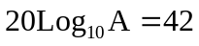
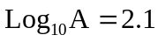 A = 10^{2 ⋅1} = 125.89
k³ = 4A = 503.57
k = 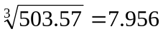

Thus

A₁ = A₂ = 7.956, A₃ = 1.989

